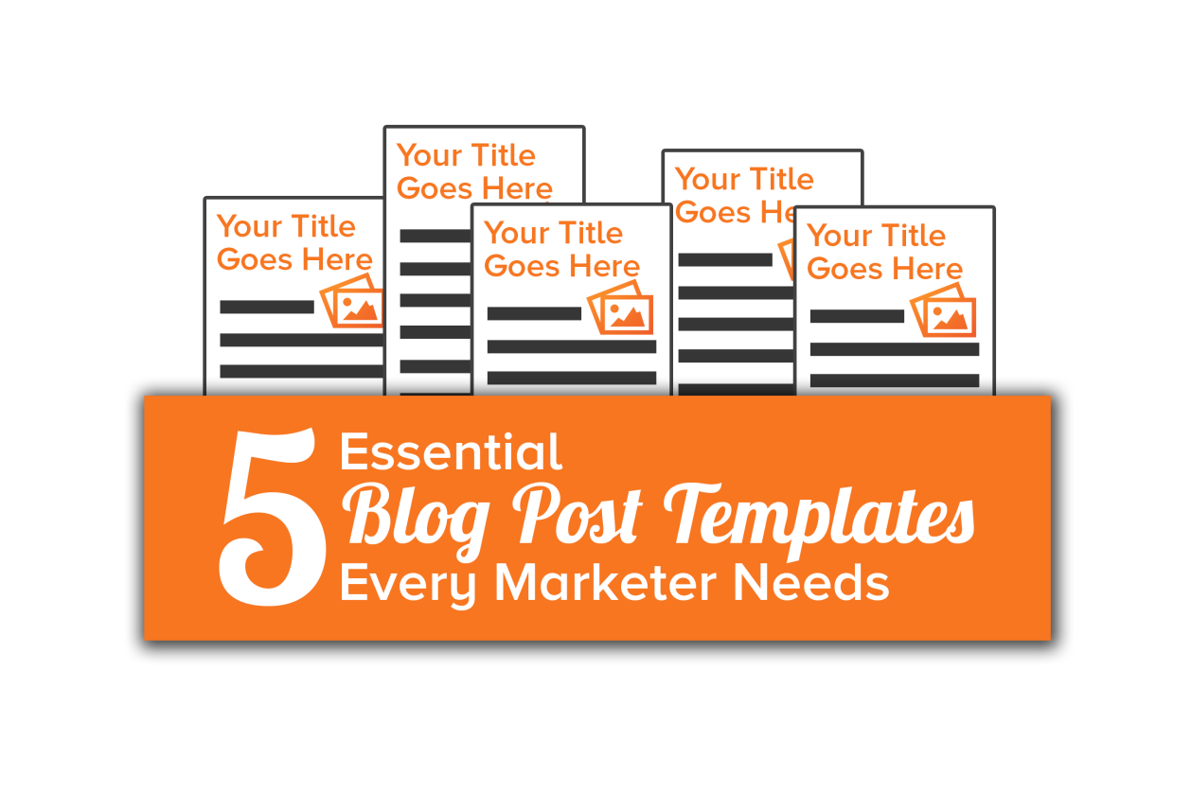

Introduction & Instructions
Hi there! Thanks for downloading our 5 free blogging templates!

What’s Included
In this folder, you’ll find these 5 blog post templates to help you write great blog posts faster and easier:
- The How-To Post
- The List-Based Post
- The Curated Post
- The SlideShare Post
- The Newsjack Post
Each template includes:
- An overview of the blog post type;
- Every step involved in planning and writing the post from start to finish;
- Text boxes to write your own notes or blog post copy;
- Additional tips and recommendations; and
- Links to examples of that blog post type to reference for inspiration.
Since some of the steps involved in writing a blog post are similar no matter what type of post you’re writing, you’ll notice some of the steps are nearly identical across all templates. However, all examples and additional resources pertain to just that post type. The idea is be able to open any one of the 5 blog post templates and have all the guidance you need right at your fingertips to write a bookmark-worthy blog post.

How to Use the Templates
Open up the template for whichever blog post you’re interested in working on, and just follow the directions provided.
The textboxes in the templates look like this, and will expand as you type. Pretty cool, huh?
Once you’re done filling in the template, you’re ready to copy and paste your blog post copy from the text boxes into your blogging platform to prepare for publishing.
Although you can print the template and fill the text boxes in with notes, the text boxes themselves aren’t that big to start off, so there’s not a ton of space to start drafting by hand.
It’s best to open up the template in Microsoft Word. That way you can save your progress, come back to it later if need be, and copy and paste between the template and your blogging platform.

Caveats
The template content we’ve provided here is not intended to be copied and pasted into every blog post you write. That results in duplicate content for which you'll be seriously punished in the SERPs.
These templates simply help you start putting pen to paper (or cursor to screen), and help you think through the structure and process of a blog post to make the whole writing experience far less painful. We encourage you to swap in synonyms for words and phrases you see in the template to incorporate your own original language. Mix it up!
And that’s it!

Happy writing,
Shannon Johnson (and the rest of the HubSpot Content Team!)
@shannopop

P.S. For tons more information on everything related to inbound marketing, be sure to subscribe to the HubSpot Blog, and check out our gigantic library of free marketing resources.
And, if you want to know more about HubSpot, check out this video overview of our all-in-one inbound marketing software or take a peek at our awesome blogging tools.

